First Congregational Church of Saugatuck

*One Hundred And Fifty Seventh Year*

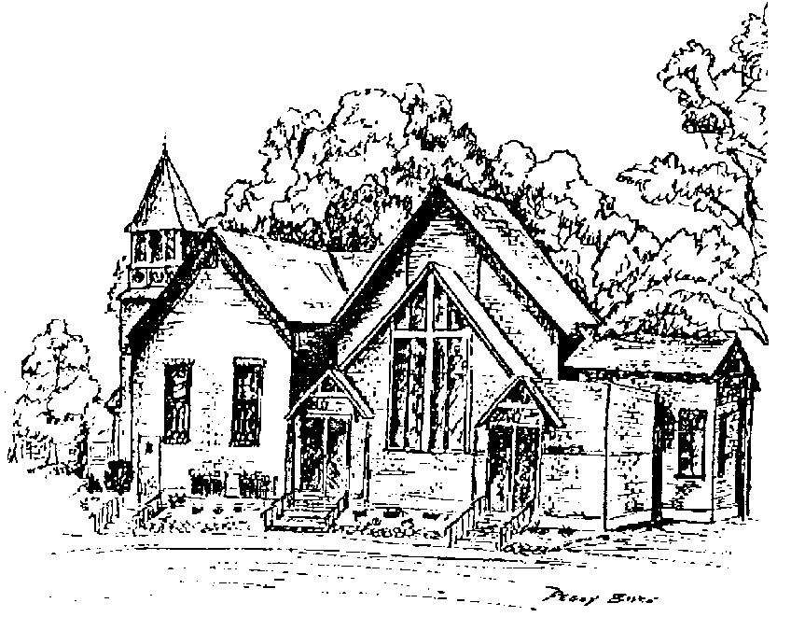

**2017Annual Report**

**For the Congregational Meeting**

**January 21, 2018**

**FIRST CONGREGATIONAL CHURCH of SAUGATUCK**

**296 Hoffman St.**

**PO Box 633, Saugatuck, MI 49453**

**Pastor: Rev. Sarah Gladstone**

**Cell: 989-640-1487 Email:** [**rev.sarahgladstone@gmail.com**](mailto:rev.sarahgladstone@gmail.com)

**Website:** [**www.1stcongregational.net**](http://www.1stcongregational.net)

**Office: 269-857-2929 Email:** [**office@1stcongregational.net**](mailto:office@1stcongregational.net)

***Loving God, One Another and Our Communities for over 150 years***

***Table of Contents***

Previous Year Annual Meeting Minutes (January 15, 2017) Page 2

Clerk’s Report Page 3

Pastor’s Report Page 4-5

Moderator’s Report Page 6

Diaconate Board Report Page 7-8

Sunday School Report Page 9

Trustee Board Report Page 10

Treasurer’s Report Page 11-12

Balance Sheet Previous Year Comparison Page 13

Profit & Loss Budget vs. Actual 2017 Page 14

Funds as of December 31, 2017 Page 15

2018 Budget (2017 Comparison) Page 16

MINUTES OF THE 156TH ANNUAL MEETING

FIRST CONGREGATIONAL CHURCH of Saugatuck, MI

Sunday, January 15, 2017

* Moderator Jon Van Raalte called the meeting to order at 11:18 am.
* Pastor Sarah Gladstone read a devotional passage..
* David Edwards offered the opening prayer.
* Betty White offered the memorial to those who have passed away.
* Motion to approve the 2016 minutes by Brad Rudich/Cathy Brockington, passed.
* The proposed budget for 2017 was presented by Phyllis Yff.  She explained that there will be savings in the staff budget because the pianist will be off one Sunday so we can have an organist, and the secretary has gone to hourly wages.  Several other areas will be cut.  She outlined the duties of the new staff position of sexton, which would include custodial care, minor repairs and lawn care and would begin in April.  Kathy Plapp made a motion accept the proposed budget with an amendment to increase the CE Director’s salary to $9000.  Cathy Brockington seconded, but the motion failed to pass by a show of hands.  Brad Rudich made a motion, seconded by Graham Duryee to accept the budget as proposed.  Motion passed also by a show of hands.
* The Slate of Nominations includes Cathy Brockington as Benevolence member of the Board of Trustees.  She, however, decided to fill the vacant slot of Publicity on the Board of Trustees with a term of 2017 to 2019.  Kirke White volunteered to fill the At Large position on the Board of Trustees for one year.  This left three empty positions on the Board of Deacons, one empty position on the Board of Trustees and no candidate for Church Treasurer.  Brad Rudich made a motion to approve the slate, seconded by Pat Gentry.  Motion carried.
* Pastor Sarah Gladstone reported that our congregation has been chosen to represent the “small church” at a workshop called “The Thriving Church” in the upcoming National Convention of the NACCC in Piedmont in June.  Since 80% of the Congregational Christian churches are small, this is quite an honor.  Sarah said she will be calling together focus groups in the spring to create a profile of our church, showing our strengths, weaknesses and goals for the future in preparation for her presentation at the workshop.
* Moderator Van Raalte told a story demonstrating the need to trust in God and encouraged the congregation to make 2017 a year of fun.
* Pastor Sarah outlined the theme for 2017 “Joy to the World,” depicted on the bulletin board which will greet everyone at the entrance to the church.  This includes opportunities for mission for each season, Bible study, exercise groups and ways to use our kitchen to serve the community.
* After a closing prayer by Pastor Sarah, the meeting adjourned at 12:40 pm.

Betty A. White, Clerk   .

**Clerk’s Report 2017**

**Births**

**Zodiana Karen Brockington          2/2/17**

**Deaths:**

**Jane Van Dis                                   1/11/17**

**Henry Hoppe (nonmember)          3/31/17**

**James Boyce Jr.                              4/2/17**

**Janel Davis                                      5/28/17**

**Gloria Gilmer (nonmember) 6/11/17**

**Deborah Baker (former member)  7/23/17**

**Loretta Cuellar (former member)  8/10/17**

**New Members:**

**Dean Lampen**

**Meagan Lampen**

**Virginia Stuart**

**Transfers:  None**

**Weddings:**

**Eric Kramer to Brittney Hoszkiw  6/10/17**

**Logan White to Maria Kieft           12/30/17**

**As of December 31, 2017, membership count remains at 150**

**Betty A. White, clerk**

**Pastor’s Report 2017**

Presented at the 157th Annual Meeting on January 21st, 2018

“Don’t hesitate to be enthusiastic- be on fire in the Spirit as you serve the Lord!”

Romans 12:11

Dearest Faith Family,

At worship on New Year’s Eve, we took part in a fun old tradition called Chalking the Doorway. With sidewalk chalk we wrote words of hope and potential on the doors of the sanctuary to bless it for the New Year. Words that answered the question: what do we hope people experience in this place in 2018? Happiness, inspiration, service, thoughtfulness, solace, celebration, joy, love, community, justice, honesty, encouragement…. And many other blessing words soon began to appear.

These words and ideas acknowledge things that we, as a family of God, are naturally gifted towards. The Women’s Fellowship has a wonderful ministry of hospitality towards families who are grieving through hosting funerals and memorial luncheons. Our worship services aim to be thoughtful and inspiring each and every week. Our creative minds come together to craft energizing special worship celebrations like Holy Humor Sunday, Heritage Sunday and our outdoor worship series in the summer. Our Tuesday night bible study has sought to foster community and give a home for honest conversations on justice. Our mission projects over the past year have been graciously and enthusiastically sponsored by our congregation. For all of this remarkable ministry work, I applaud you all! And ask, of course, that this continues into our new year together!

But, as I dwelled on the words that we readily wrote on the doorway, there were a few that I later felt were absent: zeal, a thirst for the spirit, invitation, revival, that enthusiasm that Romans 12 talked about. And so, this is what I encourage you all toward this year- enthusiasm. It is natural for us to put effort into our fellowship and service, but perhaps, it is not as natural for us to prioritize a simple zeal for the Spirit. And I admit I am chief among you in this! I am happiest being a busy worker bee for the kingdom of God- if there is a task to be done, a service project that needs my elbow grease… I’m your girl! But how often do I remember to sit in quiet awe of the Creator? To study the Word of God, not because I’m preaching on it this Sunday, but because of its infinite beauty and timeless relevance? How often do I wake up in the morning ready, really ready and eager, to spread the love of God?

2017 was a steady, foundational kind of year. Our programming went smooth, our giving was bold, our worship attendance climbed a bit, and our leadership was full of ideas and plans for the future. All in all, I’d say that this was a confidence building year. A time of deep self- assuredness, where we all could acknowledge that we are indeed going somewhere together.

In 2018, I call upon our community to be enthusiastic and flush with zeal in our ministry! May we all take the confidence that we built together as a community in 2017 and own it!

**This is the time** to open the Sanctuary doors wide and invite in our friends and neighbors.

**This is the time** to step into leadership roles because we know that there is Kingdom work to be done.

**This is the time** to dance, sing, create and praise together simply because we can and that God is good!

**This is a time** for Spirit driven vision!

Thank you all for your work and your presence this year- your ministry has been such a joy to witness. I’d like to especially thank:

* Jon Van Raalte, Moderator, for paving the way for such a confident year.
* Phyllis Yff, Treasure, for going above and beyond in her service to this church.
* Kathleen Slawson, our recently retired Office Manager, for her many years of hard work.
* Doris Hicks, our new Office Manager, for being filled with grace and patience as she took on that role.
* Our leadership boards, for their countless hours of dreaming, praying and serving.
* And finally, Timothy Terlouw, for always being willing to help me move the heavy communion table, or stop by the church to make copies before date night, or listen to terrible sermon openers to give feedback… thank you! I’m looking forward to the church getting to know you better starting in June 2018!

Let’s have a re-MARK-able year!!

All together in Christ!

Respectively submitted,

Rev. Sarah Gladstone

**Moderator’s Report 2017**

In the world of fine wines, certain years are known to be much better than others. It’s all about the grapes. If the climate is great for growing, and the harvest is good, the wine is better. In our own lives, we have good years and disappointing years. Our church, as a family, is very much the same. I’m not sure what your personal harvest was like this year, but be assured, you played a part in a bountiful harvest at First Congregational Church. It was just what we needed.

Last year, as I wrote my report, we had just come off a very trying year and I think we all looked forward to 2017 with hope and anticipation. Looking at the big picture, I feel it was a great year. It isn’t because we did any one amazing thing or that we accomplished a hundred. Instead, the things we chose to do, we did well. We are blessed to have Pastor Sarah and I am thankful for her work and her heart. Under her leadership we have found firm ground and it seems we took steps to be a happier congregation. Our finances are better. Our worship continues to improve. Most importantly, we are giving people opportunities to strengthen their faith. I believe we are all better when we can strengthen our relationship with Christ. If you don’t feel that happened for you, consider that you may have played a role in strengthening the faith of a friend. Sometimes you follow the light and sometimes you light the way.

I tend to be positive in life. It has always helped me. I always look at the New Year with optimism. In the spring, I get excited about Tigers baseball and what the season may offer. In the fall, the new school year for my children brings excitement and opportunities. I look for ways to start fresh. However, sometimes a positive outlook seems to lead to even bigger disappointment. That is when I try to look for God. Where is He in the disappointment? If I can find Him, I know everything is ok. Then I might find the lesson or the proverbial “silver lining”. He never seems to let me down. So, here is my positive spin: When I look at our church and our congregation, I believe we are **Rising**.

First Congregational Church is far from perfect. We the people of this church thankfully and humbly already know that truth. However, this is a great place and improving. I believe we can, and will, build on 2017 and make this year even better. What does better look like? To me, better means taking a step in our lives that brings us closer to God. Those opportunities are right in front of us.

How about a challenge to go with the positive spin?

Do something out of your routine and trust God to handle the results.

Maybe you could get involved with something at church you have never done. Make time to attend one of Pastor Sarah’s studies. Give grace and forgiveness to someone you struggle with personally. Invite someone to church or a church event. Volunteer to read scripture. Share a talent that might bring a smile or a laugh. It’s time to **Rise** and follow Jesus. This growing season is here and the harvest a waits.

Humbly Submitted,

Jon C. Van Raalte

**Diaconate’s Report 2017**

I’m blessed to work with a dynamic group of Christians! Although the Diaconate Board has been understaffed, the workload has not stopped. This group has tirelessly worked to make sure that everything we’ve done has been done to praise and honor our Lord!

**Christian Education**

* The Donut Club began using a new, dynamic curriculum, Can I Ask That?
* Two Congregational 101 classes were held.
* During the Lenten season, a soup supper and discussion of the book, Grace, by Max Lucado was offered.
* Youth Sunday was held celebrating our youth and the adults that support them.
* During the summer, an adult Bible Study was held using the Can I Ask That? curriculum.
* An intergenerational holiday pageant, Come to the Manger, was performed.
* At Advent the *“Seasons of the Spirit”* was introduced to the whole congregation.

**Congregational Care**

* The weekly staffing of the Nursery.
* Our weekly, Friday morning GROOVE class continues.
* The Shepherd List was updated.
* Visits have been made with our Home Members as well as those in Grace of Douglas.
* Pastor Sarah conducts a monthly worship service at Grace of Douglas.

**Fellowship**

* Purchases were made to keep our kitchen supplied.
* Scheduling of weekly Coffee Hour hosts.
* Three new members: Dale & Meagan Lampen and Virginia Stuart.
* Our annual summer picnic was hosted by Dale and Kathy Plapp
* A 5K Running Group was formed this year and many participated in the following races: Town Crier, Run for the Sun, Mount Baldhead Challenge and the Crop Walk.
* We celebrated our Congregational heritage with good food and fellowship at our Heritage Potluck.
* Our children (and adults!) were able to create edible Gingerbread Houses!

**Outreach**

* Kids Food Basket was a two part mission project. The first part had members of the congregation going to Peace Lutheran Church in Holland to put together approximately 700 snack packages for this organization. Later, the congregation was able to raise $1,040 to help support the Kids Food Basket.
* For Smile Train, our congregation was able to raise $2,116 which will pay for approximately six surgical procedures.
* Our congregation continues to support Crop Walk which works to end hunger. Members walked and raised $965, 25% of which will stay in our community (Saugatuck/Douglas) to help those in need.
* Throughout the year we gather various items for our friends at Christian Neighbors. To date, in 2017 we have collected 117 cereal boxes (during the summer); 265 boxes of JELL-O (for Thanksgiving baskets); and 25 gifts (for the Christmas Heart Gift Tree).
* At Christmas we had a special offering for our own Love Fund***.*** This offering raised $821.00 for us to help our church family and community members in need.

**Worship**

* Scheduling of weekly Scripture readers, greeters as well as procuring guest ministers when the pulpit needs to be filled.
* Dan Rusiecki organizes our Acolytes.
* This year we have an addition to our musical family. Bob Ruddy shares his musical talent as an organist once a month.
* We have been blessed to have a variety of music to help us in our praising of our Lord! Music was provided by our own Choir as well as guest musicians: Still Life, Sue Edgecomb Dickins (clarinet solo); Adrian and Sharon Van Houten; the Boyce Family; as well as a special duet with Dave Edwards (piano) and Bob Ruddy (organ).
* On Ash Wednesday we hosted “Ashes to go” a drop in liturgy.
* We took part in the community Good Friday worship service.
* Three worship services were conducted on the lawn during the summer month.
* We celebrated Holy Humor Sunday.
* Youth Sunday, celebrating our wonderful youth and the adults who support them.
* Heritage Sunday, celebrating our Congregational heritage.
* An intergenerational holiday pageant, Come to the Manger, was performed.
* Having Christmas Eve on a Sunday this year gave us two very different services. The first was a casual morning hymn sing, followed by an more traditional evening candlelight service.

Before closing, I would just like to say a special thank you to our youth. This year they stepped up, sharing their time and talents in a variety of ways, whether it was through music, staffing the nursery or helping to set up for events/programs throughout the year! Their gifts were much appreciated!

Thank you for the opportunities I’ve had this year as Chair of this wonderful committee, It has been a true blessing.

In His service,

Linda Escott

Diaconate Chair

**Sunday School Report 2017**

Our Students supported the following groups with their offerings:

January - May 2017 ———Children's Hunger Fund

June - August 2017 ——— Smile Train Program

September - October —— Crop Walk

November - December ——Christian Neighbors

**Attendance:**

Throughout the year attendance has fluctuated from week to week. We are always happy for the students God brings to us.

**Field Trips:**

To support our mission of Children's Hunger Program “Kid’s Food Basket”, a congregation wide field trip was sponsored to pack lunches for the student’s weekend meal.

Via video we took a field trip under the sea to watch some sea creatures up close and personal. Thank you, Ralph Birkholz, for providing that for our program.

**Cooperation:**

We are blessed to have such talented students. Everyone is eager to participate. Students are willing volunteers. I am so proud of them!

**Helpers/Teachers:**

Our teachers are equally as talented as our youth. Each of them is very helpful in class and encourages the students in everything they are doing.

**Overall program:**

We are providing a curriculum which teaches basic knowledge of key Bible stories. We reinforce the knowledge with varied projects and activities. Our Upper Room Sunday School class memorized the books of the Old Testament.

We are currently using Seasons of the Spirit Liturgical study.

In Donut Club our students continued in “*Can I Ask That vol. 1"* by Sticky Faith. This program is designed to lead our youth through what the bible says about some tough questions. Our teacher Kathy Plapp is doing an excellent job leading our youth through the program. Beginning with Advent the youth are also using Called by the Spirit materials.

**Summer Sunday School:**

We had a fun summer program using ‘Jesus Under the Sea” program. Each week our students learned about a new bible story and a sea creature. They made crafts and learned songs.

It is a blessing to be able to serve the children and the congregation.

Diana Theilgaard-Hoppe

**Trustee’s Report 2017**

The Trustee Board has had a rosy year.

We hired a new sexton that has us saving money and provided us with a higher standard of service for our building and grounds. Becky Carten-Crandell of All-In-One Cleaning and her staff have done an outstanding job. In addition, we hired a new office manager, Doris Hicks, due to the retirement of Kathleen Slawson. Doris has stepped in comfortably with our affairs and has already proved indispensable.

This year we have:

* Painted the exterior of the utility shed
* A.C. and furnace repairs
* Sprinkler repairs
* Replaced the motor in the handicapped door
* Had minor roof patching
* Had outside windows cleaned
* Fixed parking lot drain
* Approved additional hearing loop devises

Our kitchen project continues to evolve with:

* Purchase of a commercial water heater
* Ceiling tiles
* Hand washing sink and drain installed
* Shelving and Dutch door installed

A special thank you to Phyllis Yff for everything she does to make things go smoothly.

Thank you to Pastor Sarah for her involvement and encouragement.

Finally, thank you to all my fellow board members: Kristyn Boyce, Kirke White, and Cathy Brockington. I appreciate the time and dedication of all who come forward in service for our church

Submitted on behalf of the Board of Trustees

Dave Edwards

Chairman

**Treasure’s Report 2017**

To all participants in the life of First Congregational Church, as we look back on our accomplishments of 2017, we can do so with pride. Our gifts of time, talent, and treasures have made a difference in our church, our community, our nation, and even internationally. Now it’s time to imagine and prayerfully consider what 2018 has in store for us.

“Authenticity over perfection, unity over uniformity – real people who come together for the love of the Lord. We are a dedicated community of faith. Our dedication is shared through our goal: *Loving God, loving each other, and serving our community.”* That's what we're about. It's simple to say, harder to live. Every single week, we find a way to love God through worship, one another through fellowship, and the Saugatuck/Douglas area by sharing our story. We don't always get it right but we have fun trying. Around this Mission is gathered all of our personal stories and experiences of Christian faith in action. Making our stories possible is the generosity of our congregation who unselfishly support the church. You are the people who provide and maintain both our physical facility and property, and our many spiritual ministries to each other and our community. We invite all of those who participate in our church’s life to engage in developing and furthering First Congregational Church’s stories of faith in action for the year 2018.

*BUILDING COMMUNITY*

* We are thankful we have beautiful spaces for worship, fellowship, and outreach – a mainstay in the community since 1860. Our facilities provide a gathering place where we can praise God, share hospitality, and experience inspiring ministry.
* We worship together in our large *sanctuary* surrounded by the power of God’s love. *Classrooms* provide functional places for learning and spiritual growth. Our remodeled *kitchen* allows us to prepare food for sharing. We gather in *fellowship hall* for coffee hour and community get-togethers. The church *grounds* are open spaces for locals and visitors alike.
* We invite the community to share our building by welcoming the local scout troops, Lakeshore Community Chorus, weekly recovery group meetings, confirmation classes, MCCC meetings, Groove classes, weddings, bible studies, outdoor worship services, and the many activities of our Women’s Fellowship.

*LOVING GOD*

* All are welcome to worship and celebrate God’s love and grace. Through song, sermon, and prayer we embrace the word of God and explore our relationship with God.
* In Sunday School our staff and volunteers share their gifts of faith and teaching to our young through stories, songs, crafts and activities.
* In Confirmation and new member classes we welcome those seeking to share in our ministries.

*LOVING OUR NEIGHBOR AS OURSELVES*

* Our gift giving in 2017 included Christian Neighbor’s food pantry; packing snacks for students; participating in CROP walk; entering 5K races, our Love Fund, and supporting the Sunday school’s smile train ministry. We honor God by living the words Jesus spoke “It is more blessed to give than to receive”.
* Each of us, in our own way extends the ministry of our church throughout our community and beyond. God is with us when we gather - from worship to education to serving – building in us team spirit and a light showing that we are alive, well, and willing to share our God-given life as neighbors with all.

The proposed 2018 budget of $119,473 is our projection to fulfill our Church’s missions, programs, and visions. Contributions were increased to reflect changes in 2017 giving levels. Delegate travel allowance was reinstated. Personnel changes lowered our staffing budget. We continue to work towards prioritizing building improvements such as signage, carpeting, sound system upgrades, landscaping, and a new roof.

Respectfully submitted by Phyllis Yff, Treasurer.

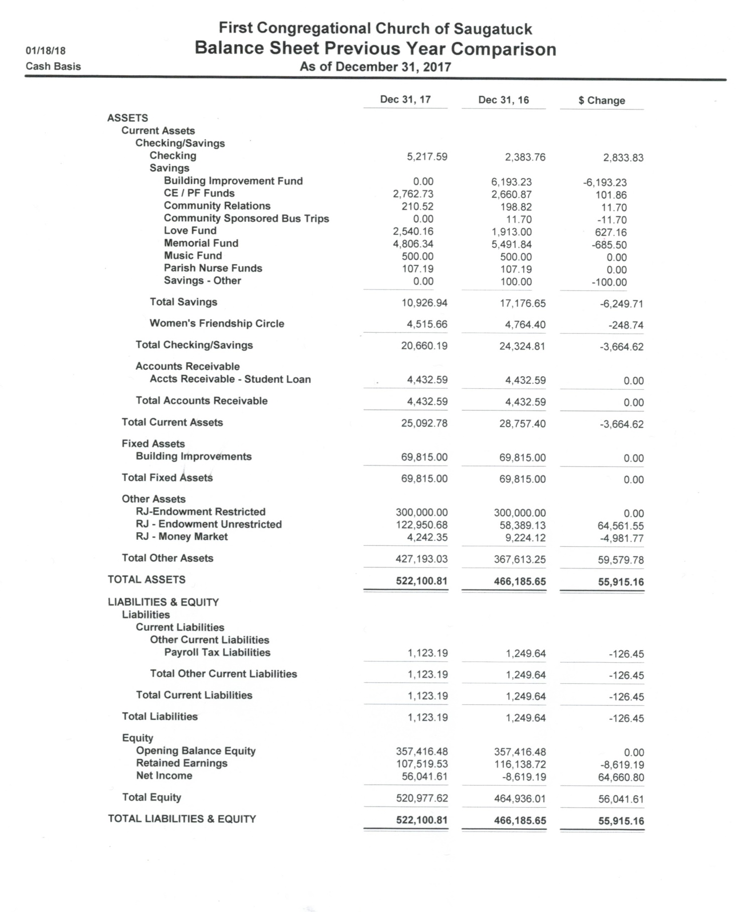

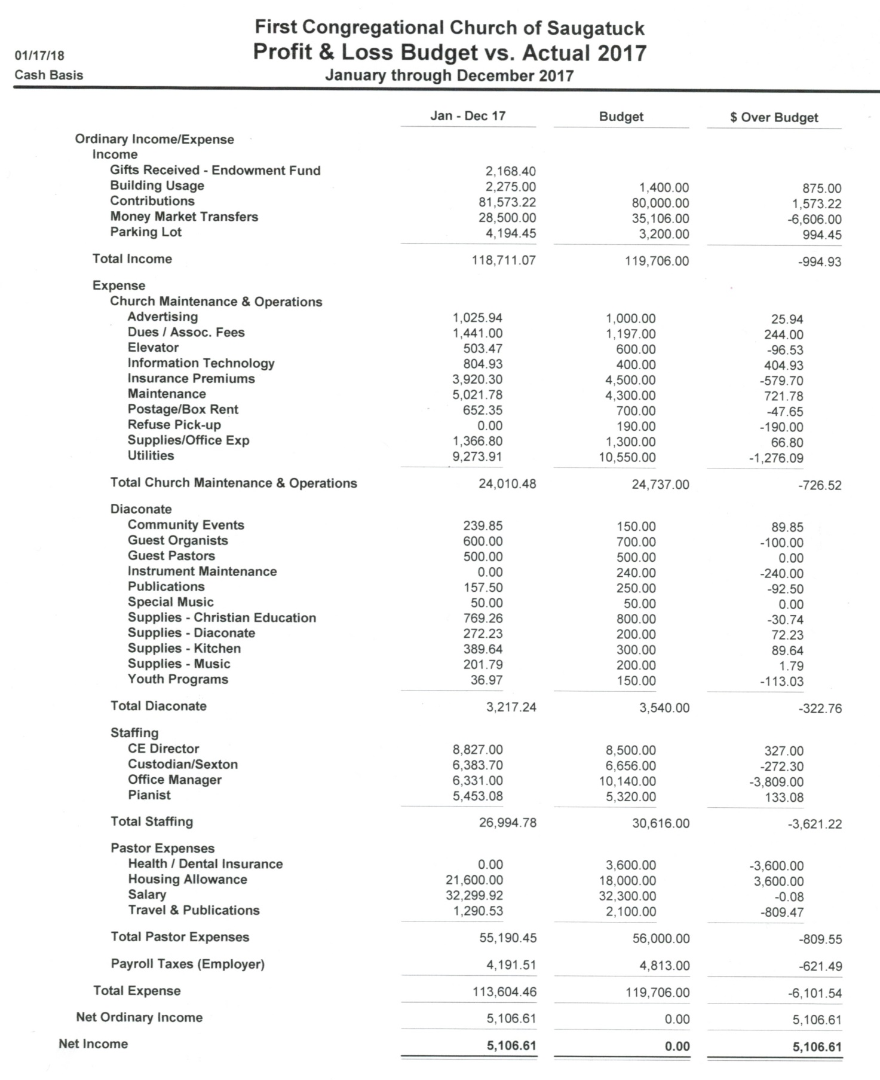

**Funds Balance Sheet as of December 31, 2017**

|  |  |  |  |  |  |  |
| --- | --- | --- | --- | --- | --- | --- |
| **Savings Account** | **1/1/2017 Balance** | **Contributions** | **Withdrawals** | **12/31/17 Balance** |  | **Notes** |
| Building Improvement | $ 6,193.23 |  | $ 6,193.23 | $ - |  | Kitchen Project |
| Christian Ed/Pilgrim Fellowship | $ 2,660.87 | $ 233.10 | $ 131.24 | $ 2,762.73 |  |  |
| Love Fund | $ 1,913.00 | $ 1,075.76 | $ 448.60 | $ 2,540.16 |  |  |
| Memorial Fund | $ 5,491.84 | $ 45.00 | $ 730.50 | $ 4,806.34 |  | Kitchen Project |
| Music Fund | $ 500.00 | $ - | $ - | $ 500.00 |  |  |
| Parish Nurse | $ 107.19 |  |  | $ 107.19 |  |  |
| Other | $ 310.52 |  | $ 100.00 | $ 210.52 |  | Refund deposit |
| Totals | $ 17,176.65 | $ 1,353.86 | $ 7,603.57 | $ 10,926.94 |  |  |
|  |  |  |  |  |  |  |
|  | **1/1/2017 Balance** | **Income** | **Expenses** | **12/31/17 Balance** |  |  |
| **Women's Friendship Circle** | $ 4,764.40 | $ 1,670.70 | $ 1,919.44 | $ 4,515.66 |  |  |
|  |  |  |  |  |  |  |
| **Endowment Fund** | **1/1/2017 Balance** | **Gains/Gift** | **Dividends** | **Fees** | **Draws** | **12/31/17 Balance** |
| Unrestricted | $ 67,613.25 | $ 86,623.38 | $ 4,866.04 | $ 3,409.64 | $ 28,500.00 | $ 127,193.03 |
| Restricted | $ 300,000.00 |  |  |  |  | $ 300,000.00 |
| Totals | $ 367,613.25 | $ 86,623.38 | $ 4,866.04 | $ 3,409.64 | $ 28,500.00 | $ 427,193.03 |
|  |  |  |  |  |  |  |
| **Special Funds** | Collected | Disbursed |  |  |  |  |
| Easter Flowers | $ 310.00 | $ 310.00 |  |  |  |  |
| Kid's Food Basket | $ 1,065.00 | $ 1,065.00 |  |  |  |  |
| Smile Train | $ 2,121.00 | $ 2,121.00 |  |  |  |  |
| Christian Neighbors | $ 236.00 | $ 338.00 |  |  |  |  |
| Pointsettias | $ 206.00 | $ 206.00 |  |  |  |  |
| Other | $ 414.06 | $ 414.06 |  |  |  |  |
| Totals | $ 4,352.06 | $ 4,454.06 |  |  |  |  |
|  |  |  |  |  |  |  |

**2017-2018 Budget Comparison**

